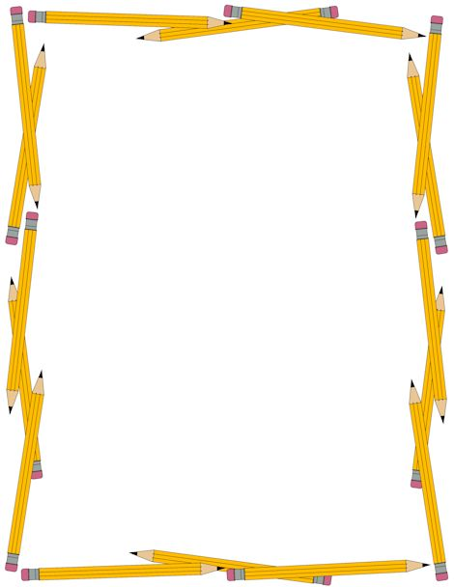
August 2021
Welcome to the Red Team!
We are eager to have your child as part of our team this year! Eighth grade year is a very important year filled with many academic endeavors as well as team activities. Our goal is to work with you to give your child the best possible eighth grade experience. To get us off to a successful beginning, here is a list of supplies for classes:
- Math – binders will be kept in the classroom:
  - 1.5 or 2-inch binder
  - Either a folder or binder divider
  - Lined filler paper
  - Pencils are a MUST

- Language Arts, Science, and History will share a binder with the following:
  - One 2.5 or 3 inch three-ring binder – preferably not zippered
  - Two packages of white, lined filler paper (college rule)
  - Two dividers for the binder
  - 3 Three-hole punched folders – one for LA (which can double as a divider), one for Science, one for History. (Science and History only need folders, no sections)
  - Blue or black pens

- Miscellaneous information:
  - Lockers will not be in use again this year, so please ensure your child has a bookbag to carry their belongings.
  - Lunch will be free for all students for this school year and will be held in classrooms again this year.
We are working to help your child transition to high school. Organization is essential to their success both this year and in their future as they become more independent. If you need help attaining these supplies for your child, please do not hesitate to let one of us know and we will be happy to help.
We are very excited for the upcoming school year! If you have any questions please contact Mrs. Rand at rands@plainfieldschools.org. We look forward to a successful year together.
Sincerely,
The Red Team Teachers
Mrs. Dixon (Math) Mrs. Rand (Science) Ms. Witham (Language Arts) Mr. Grant (History) Ms. Skulczyck (Special Education)

